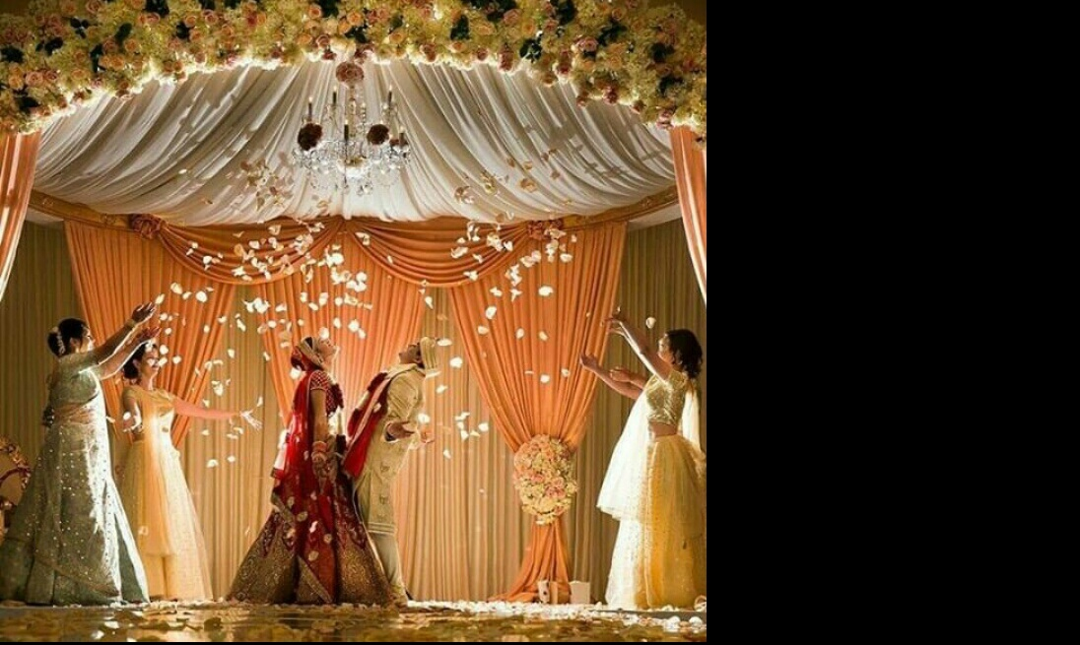
|| Shree Gajanana Prasanna ||
One Moment, Two Hearts, Three Knots, Seven Steps & Lifetime Togetherness ... !
I request your
Presence on the Auspicious occasion
of my Marriage with,
“ Laxmi ”

Join us on our special day
@ Pattanshetti Kalyan Mantap,
Bharathi Nagar, Haliyal Road, Dharwad.
On Thursday
23rd November 2017 * 12:16 p.m

